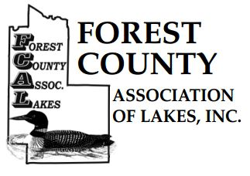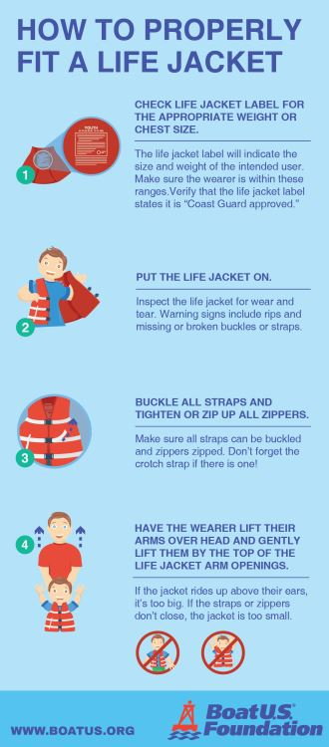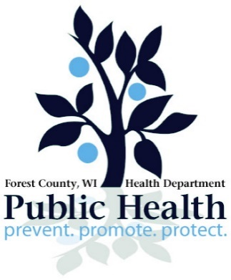L

**State law requires that there be a life jacket on board for each passenger on the vessel.**

Please call the Forest County Health Department with any questions or concerns at 715-478-3371

**Rules and Regulations:**

1. Life jackets are available on a first-come, first-serve basis.
2. Parents/guardians are responsible for making sure their children are in the right sized life jacket. If the size is incorrect, the life jacket will not work correctly.
3. Borrower assumes all responsibility and liability of life jacket use/non-use.
4. Borrower will not hold liable any party involved in the distribution of life jackets.
5. Borrower must inspect the life jacket prior to use to make sure that it is in good working condition.
6. Return life jackets to this station when you are done using them.

**Please Use and Return**

**LIFE JACKET LOANER STATION**